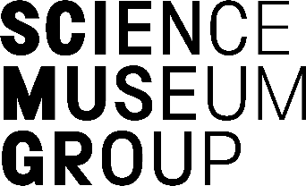
VACANCY INFORMATION PACK
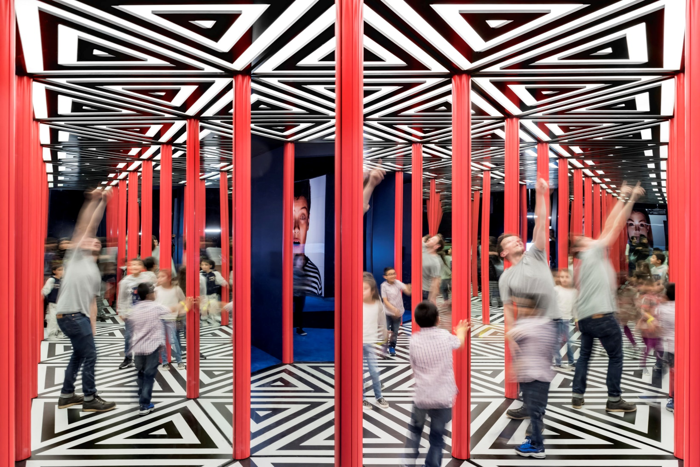
MEDIA LICENSING EXECUTIVE
OUR MISSION AND VALUES:
At the Science Museum Group, we make it our mission to Inspire Futures. Our talented and dedicated colleagues are guided by five values that encapsulate simply what we’re all about:
– we think big, pushing the limits of
what’s possible;
– we challenge ourselves to
reveal wonder;
– we use our passion, expertise and creativity to share authentic
stories;
– we aim to ignite curiosity in our
audiences and our colleagues; and
– we take pride in being open for all

Closing Date: 11pm on Sunday 31 July 2022
Interviews expected 8 – 11 August

Contents:
About the role
What you bring
How to apply

MEDIA LICENSING EXECUTIVE
Department: Cultural and Commercial Partnerships (CCP) Hours: 35 hours per week
Contract: Fixed term contract, until April 2023 Salary: £25,000 per annum
Reports to: Media Licensing and Content Manager Hybrid working: Available
Location: Open to SMG site, with regular travel to Science Museum, London
Date: July 2022

ABOUT THE ROLE:

The Cultural and Commercial Partnerships team is critical in realising this aim as part of the Group’s commercial Enterprise department. We raise SMGs profile nationally and internationally, commercially leveraging our brand, content, and skills and create new partnerships worldwide. Our picture library hosts wholly owned collections from 5 National Museums, and third-party collections including Royal Botanic Gardens, Kew.
We licence images, ranging from some of the oldest photography in the world, including the William Henry Fox Talbot Collection, stunning object photography by our own photo studio and some of the most newsworthy, such as the Daily Herald Archive. We also licence footage, including the first ever colour film, and artworks, such as the Railway Posters from the 20th Century.
As Media Licensing Executive, you will be working on building and maintaining relationships with key licencing clients. The main purpose of your role will be sales, business development, proactive engagement with clients, contract negotiations, chasing up expired licences and various marketing activities. Working with contacts across the organisation and externally, you will have a wide range of stakeholders on a variety of projects, facilitating project delivery.
This role can be based at one of the following Science Museum Group sites, depending on your preference – London, Bradford, York or Manchester. Although you will be required to regularly visit London where the team is based.
WHAT YOU WILL BE DOING:
- Working across TV, Film, Publishing and Heritage sectors developing new licensing opportunities, working with our wholly owned and third-party collections
- Work with the Media Licensing and Content Manager to devise business development strategies; subsequently implementing these.
- Undertaking research within our collections to identify client requested content for licencing
- Undertaking market analysis for designated regions and activities and feeding back to Media Licensing and Content Manager to initiate new opportunities for future financial growth accordingly.
- Negotiate agreements for new projects with key clients
- Answer general telephone, email and written enquiries about the picture library’s new business activities and undertake general administrative duties as required.
- Carry out other ad-hoc duties as required by the Media Licensing and Content Manager.
- Continuously demonstrating inclusive behaviours, valuing everyone’s contribution, and promoting a culture of openness
- As a colleague at SMG, you will learn about our Health and Safety Policies, procedures and risk assessments, allowing you to take care of your own personal safety and that of others.
WHAT YOU BRING TO THE TEAM:

- Good understanding and background of media (image, footage and sound) licencing, photography, intellectual property, client relationship management and business development
- Experience of successfully building and stewarding relationships between individuals and organisations to deliver productive, commercial outcomes
- Demonstrable experience of negotiating multiple client projects simultaneously across publishing, tv, film and museum exhibition sectors
- Demonstrable planning and resourcing skills showing evidence of managing resources carefully
- Excellent communication skills, to effectively convey clear messages across a wide range of people and audiences
- A good visual eye for aesthetics and photography
- Proven ability to work with digital asset management systems
- Proven ability to work under pressure to meet targets and tight deadlines calmly and effectively
- Demonstrable diplomacy and influencing skills
- The ability to pay close attention to detail consistently, throughout busy periods
- Great stakeholder management and the ability to build good relationships at all levels
- A values-driven approach and passion for contributing to an open and inclusive organisation.

It would be good, but not essential, if you …
- Have a passion for history, science, technology or/ and photography
- Have experience working in image agencies
- Have experience of archives or collections
- Have experience working with Photoshop, Bridge and Indesign
SOME THINGS YOU NEED TO KNOW:

- You can expect to visit all Group sites in York, Bradford, Manchester, County Durham and Wiltshire, and occasionally travel to other UK locations.
- The role currently works to a hybrid working pattern, which offers flexibility to work from home. However as per the responsibilities of the position, there is still a regular requirement for an onsite presence, and travel to London for relevant meetings.
- SMG will request either a basic or enhanced criminal record check for the successful candidate, depending on the requirements of the role. We will consider every applicant on a case-by-case basis.
- SMG will support any eligible applications to ‘Access to Work’, a government scheme which helps disabled employees meet additional access related costs at work.

HOW TO APPLY!
Interested? We welcome your application. You can apply for this position via our Careers site. Please answer the following question(s) in the Supporting Statement section of the application form.
YOUR SUPPORTING STATEMENT
- Please describe your experience working with media licencing including details of the relationships you have developed with clients.
- Please describe a time that you have delivered a financially successful project (or sale) from start to finish - from identifying an asset to licencing it to a client.
At the end of your answer to question 2, can you please state your notice period?
HOW WE CAN SUPPORT YOU:
- We’d love to hear from you. If you have any questions about the role specifically, please contact Evelyn Warner, Talent Acquisition Partner via evelyn.warner@sciencemusem.ac.uk
- If you need assistance to complete your application or attend an interview, for example due to a disability, or would like to talk to us about what we can do to support you through this process, please contact us by email or by calling 01904 685 750.
- Find out more about what it’s like to work at Science Museum Group, answers to frequently asked questions and how to find our offices (including when attending interviews) here.
- We are working hard to understand our organisation better and to foster a culture that recognises and values different backgrounds, mindsets, skills, experience, knowledge and expertise. By having greater diversity, we believe that we will be a stronger and better organisation and ultimately will be able to inspire more futures. We therefore welcome applications from those who bring difference.

